UI and use cases for “add a new product into the system” for store management system

1. Default screen:   
   (Must click button “Add a new product”)

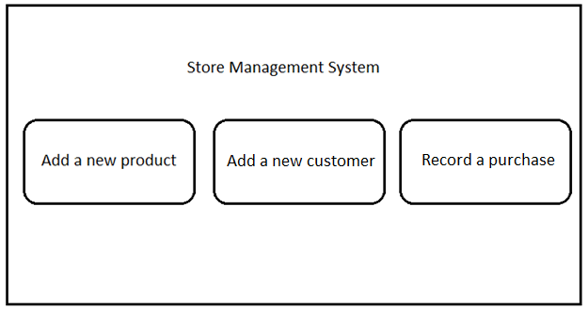

1. Display “Add a new product” screen

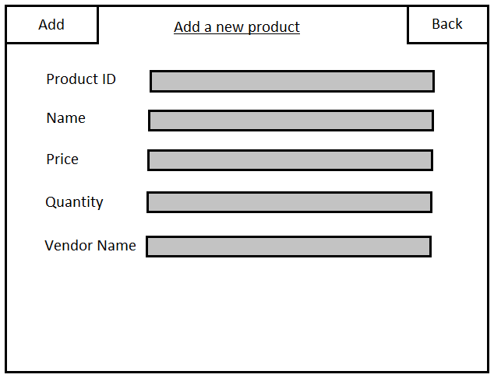

1. Input necessary information and click “Add” on the top left

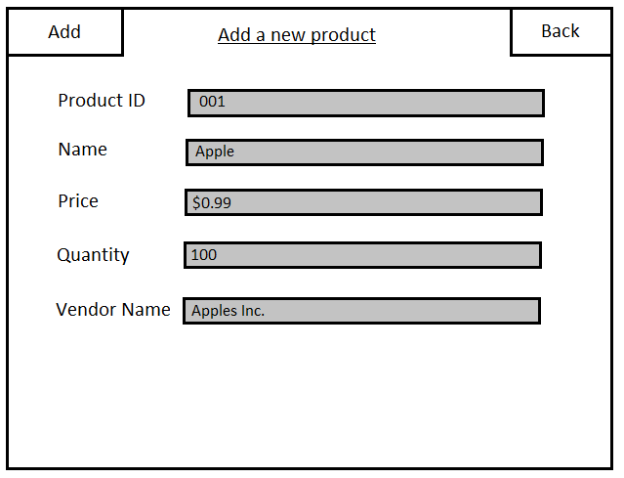

1. Go back to default screen and display “Product Added!” window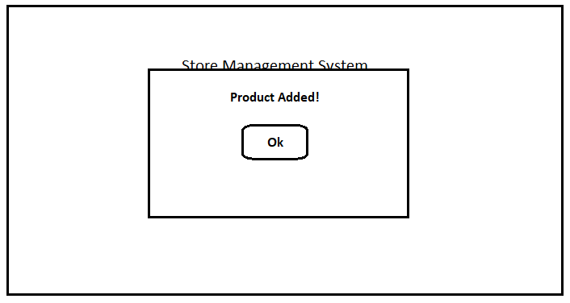
2. Click “Ok”

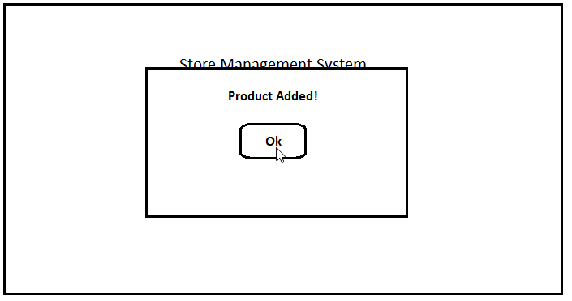

1. Display default screen



1. Default screen:   
   (Must click button “Add a new product”)



1. Display “Add a new product” screen



1. Input necessary information and click “Add” on the top left

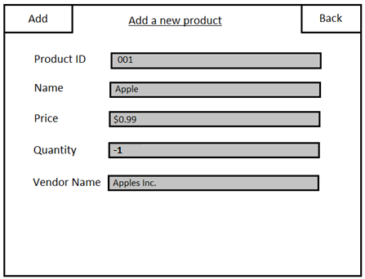

1. Display “Error with information” screen (Quantity can’t be negative)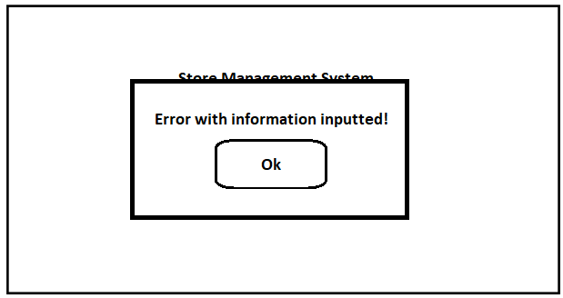
2. Display default screen after user clicks “Ok”



UI and use cases for “add a new customer into the system” for store management system

1. Add a new customer:

Default screen:

(Must click button “Add a new customer”)



1. Display “Add a new customer” screen

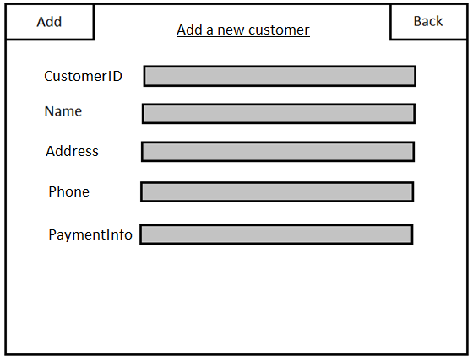

1. Input necessary information and click “Add” on top left

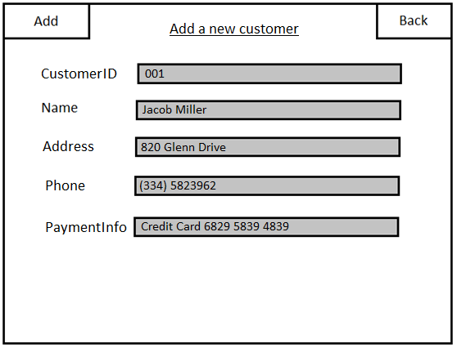

1. Go back to default screen and display “Customer Added!” window

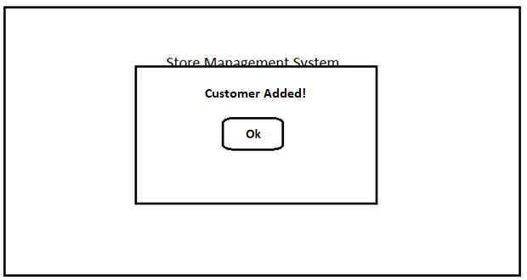

1. Click “Ok”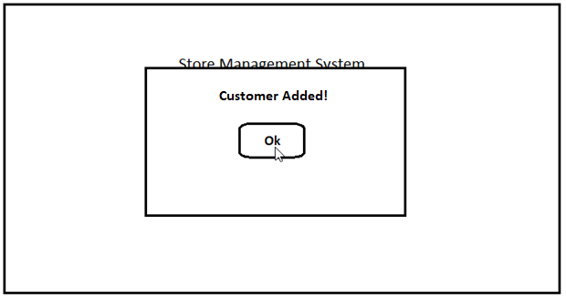
2. Display default screen



1. Add a new customer:

Default screen:

(Must click button “Add a new customer”)



1. Display “Add a new customer” screen



1. Input necessary information and click “Add” on top left

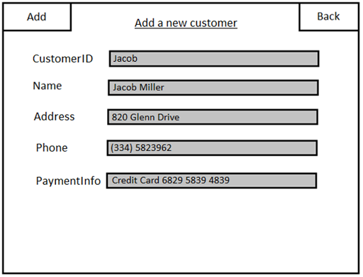

1. Go back to default screen and display “Error with information inputted!” window (CustomerID cannot be negative)

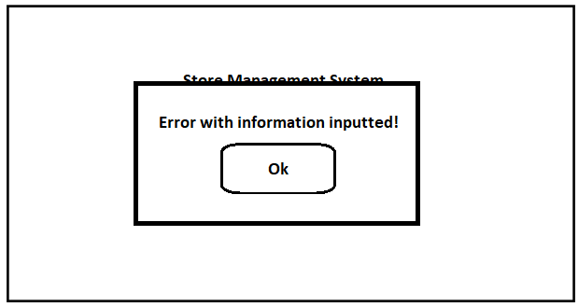

1. Display default screen



UI and use cases for “add a new customer into the system” for store management system

1. Add a new product:

Default screen:   
(Must click button “Record a purchase”)



1. Display “Record a purchase” screen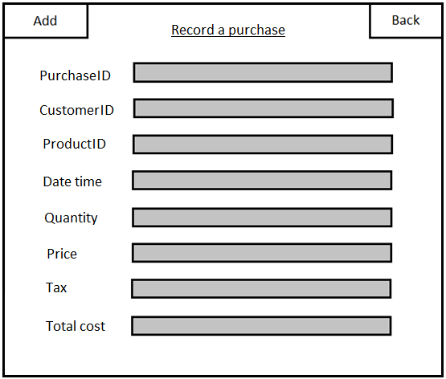
2. Input necessary information and click “Add” on top left

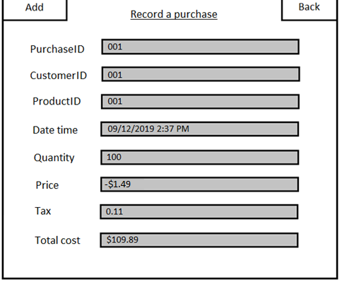

1. Go back to default screen and display “Error with information inputted!” window (Price cannot be negative)



1. Display default screen

